**Smart Monitoring and Safety System:**

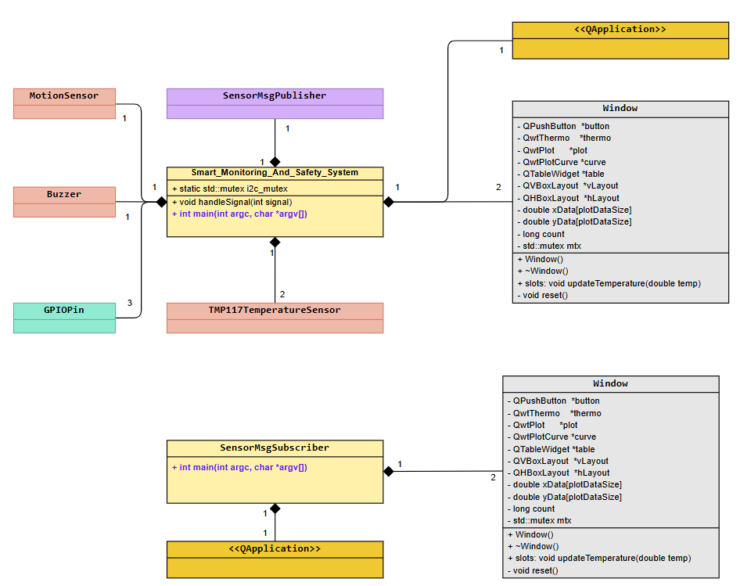

Figure 1 System/Main process – object relationship diagram.

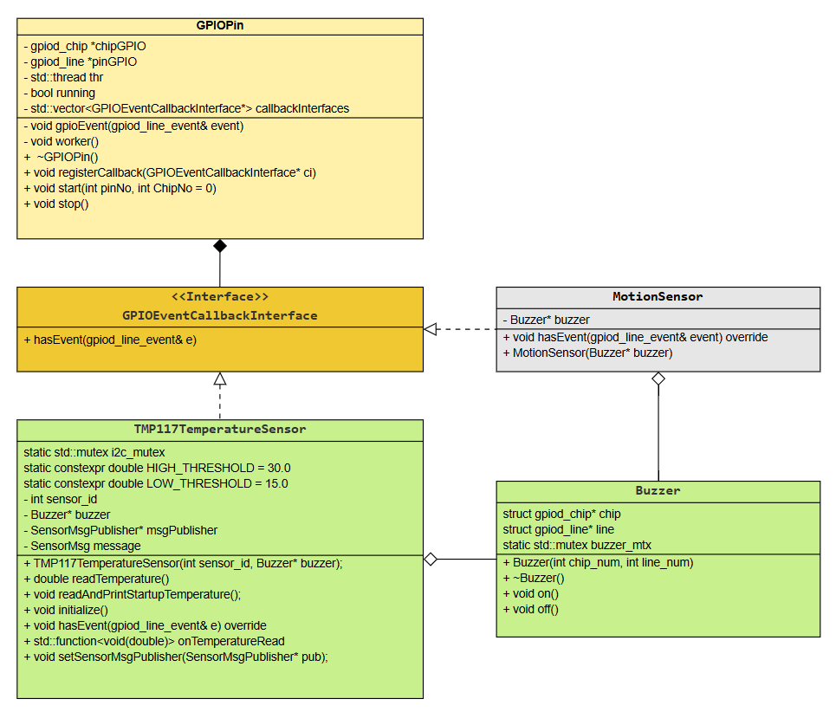

Figure 2 Class diagram for GPIO devices

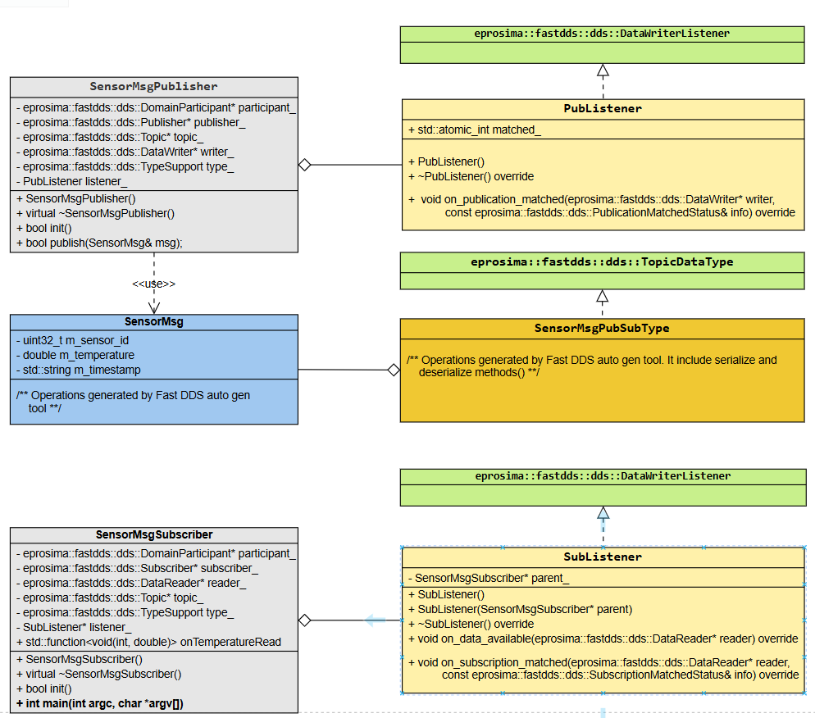

Figure 3 Class diagram of Publisher Subscriber model based on Fast DDS design model